Configuration Rationale Document

Table of Contents

Reference Documents 1

1. IMG Configuration Object 1

2. Revenue accounting and reporting 1

2.1.1 Prerequisites 1

2.1.2 Configuration Rationale / Additional Considerations 1

2.1.3 Configuration 1

3. Define commitment for commerce cloud <->CPQ and S4 4

3.1.1 Configuration Rationale / Additional Considerations 4

3.1.2 Configuration Settings 5

4. Define commitment for CPQ <-> Commerce Cloud 18

4.1.1 Configuration Rationale / Additional Considerations 19

4.1.2 Configuration Settings 19

4.1.3 Workflow from CPQ 20

4.1.4 Status Flow details from CPQ 22

## Reference Documents

|  |  |
| --- | --- |
| Document | Document Location |
| Business Process Document (BDP) |  |
| Solution Backlog |  |
| RICEFWF Catalog |  |
|  |  |
|  |  |
|  |  |

# IMG Configuration Object

*N/A*

# Revenue accounting and reporting

### Prerequisites

*Baseline configuration for Revenue accounting and reporting is available*

### Configuration Rationale / Additional Considerations

*Defined commitment is a new scenario where it is possible to roll over the unused capacity to future periods and revenue recognition happens based on consumption.*

### Configuration

|  |  |
| --- | --- |
| **Transaction Code** |  |
| **IMG Path** | Ficaimg>Integration>Revenue accounting>Define service types |

*Define new service type*

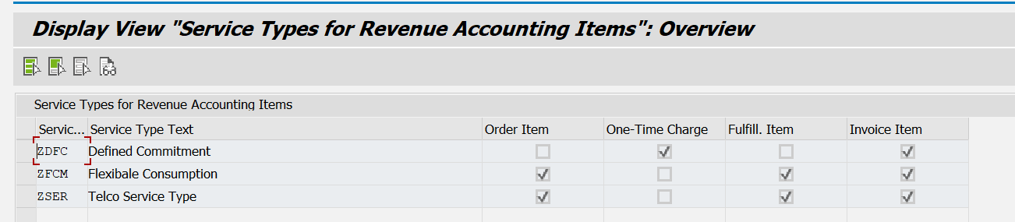

|  |  |
| --- | --- |
| **Transaction Code** |  |
| **IMG Path** | Ficaimg>Integration>Revenue accounting>Assign service ids to service types |

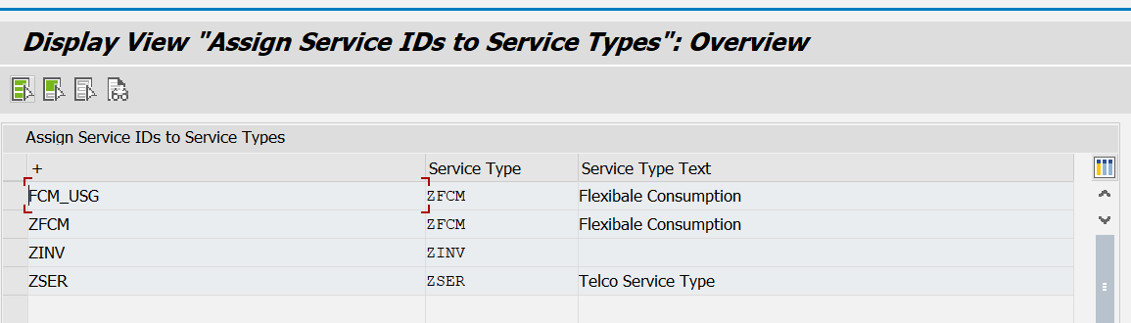

|  |  |
| --- | --- |
| **Transaction Code** |  |
| **IMG Path** | Ficaimg>Convergent invoicing>Cost posting>Define billable item cost types |

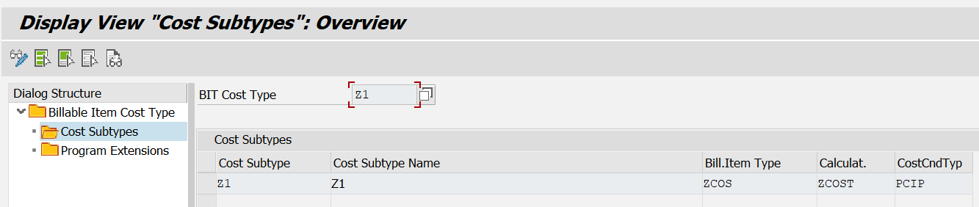

|  |  |
| --- | --- |
| **Transaction Code** |  |
| **IMG Path** | Ficaimg>Convergent invoicing>Cost posting> Maintain amount calculation key |

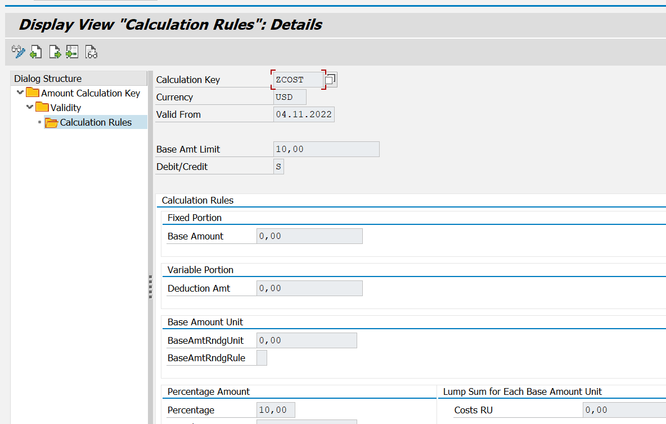

*BRF+ configuration for new POBS*

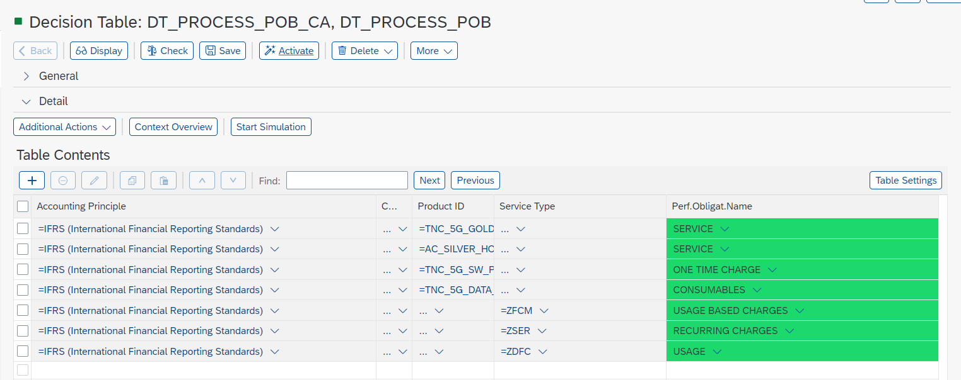

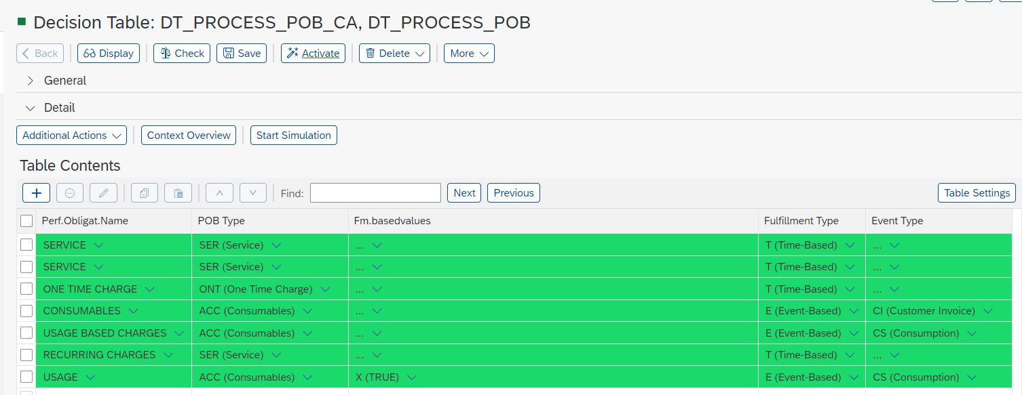

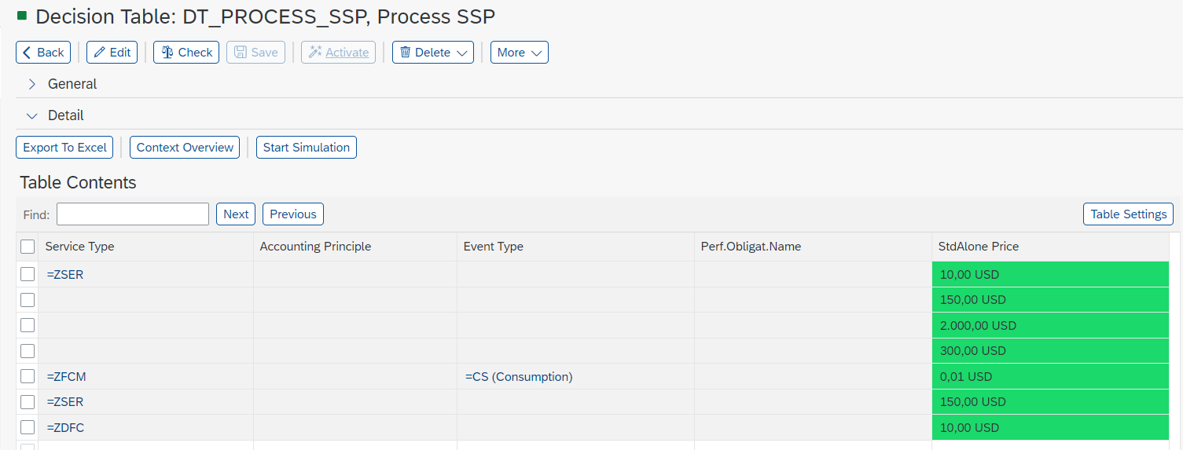

# Define commitment for commerce cloud <->CPQ and S4

Commerce cloud store front and Back office must be deployed and running in cloud. Below URL’s for reference.

Storefront URL : <https://tncb2ctelco.cuo2c7ilx-eyglobal16-d1-public.model-t.cc.commerce.ondemand.com/tncb2ctelco/en/>

Login id & Pwd : samturner456@gmail.com / 123456

Back Office URL : <https://backoffice.url>

Login id & Pwd : test / 123456

### Configuration Rationale / Additional Considerations

To Implement/ Submit Define commitment/Minimum Contract from commerce cloud, products should be replicated from S4 to commerce cloud, once products was replicated, we can replicate the Stock for the same products.

### Configuration Settings

Commerce cloud storefront and Back office should be deployed and running in cloud. Below URLs for reference.

Storefront URL : <https://tncb2ctelco.cuo2c7ilx-eyglobal16-d1-public.model-t.cc.commerce.ondemand.com/tncb2ctelco/en/>

Login id & Pwd : sameturner456@gmail.com / 123456

Back Office URL : <https://backoffice.url>

Login id & Pwd : test / 123456

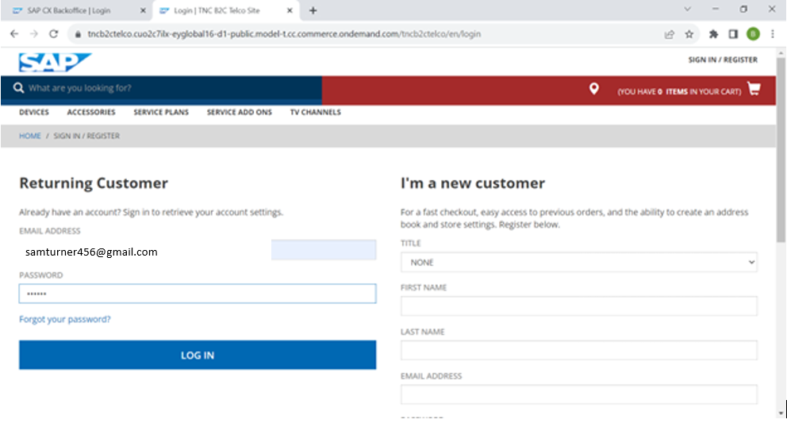

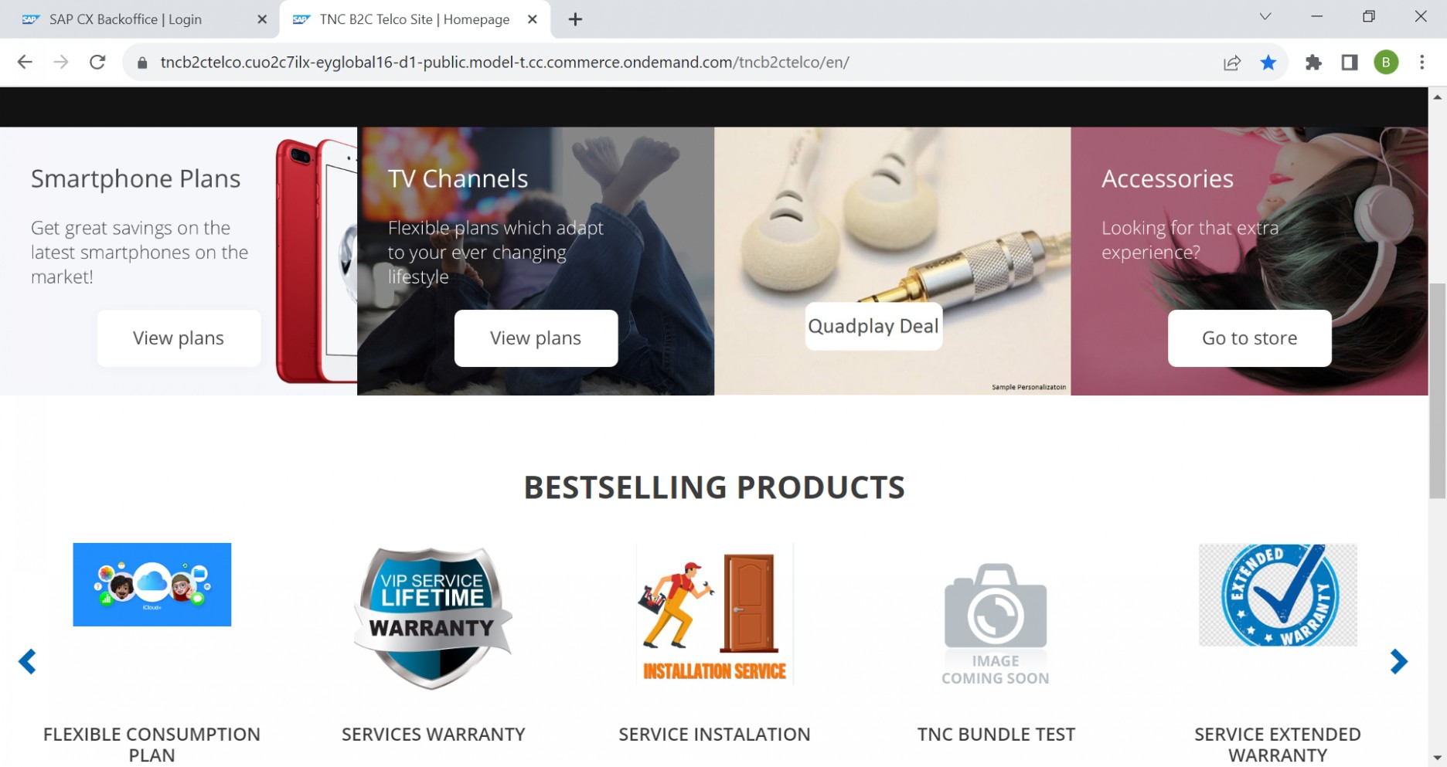

Once login into commerce cloud storefront, we can verify the replicated Product (Define commitment in our case) from S4 to Commerce cloud in Commerce back office and same can be verified in commerce storefront as well. Below Screenshot for reference.

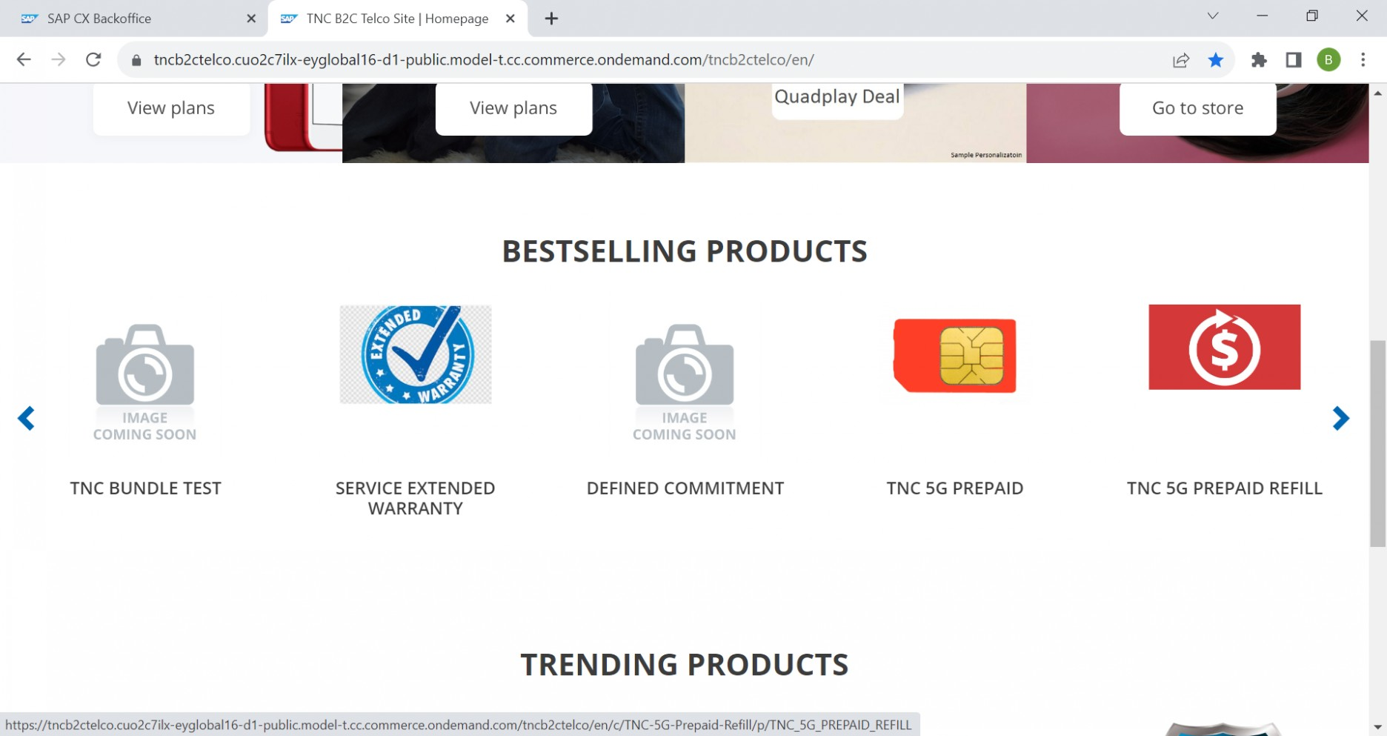

Once login into commerce cloud storefront, we can access the replicated Product (Define commitment in our case) from Commerce cloud by clicking on the same Product. Below Screenshot for reference.

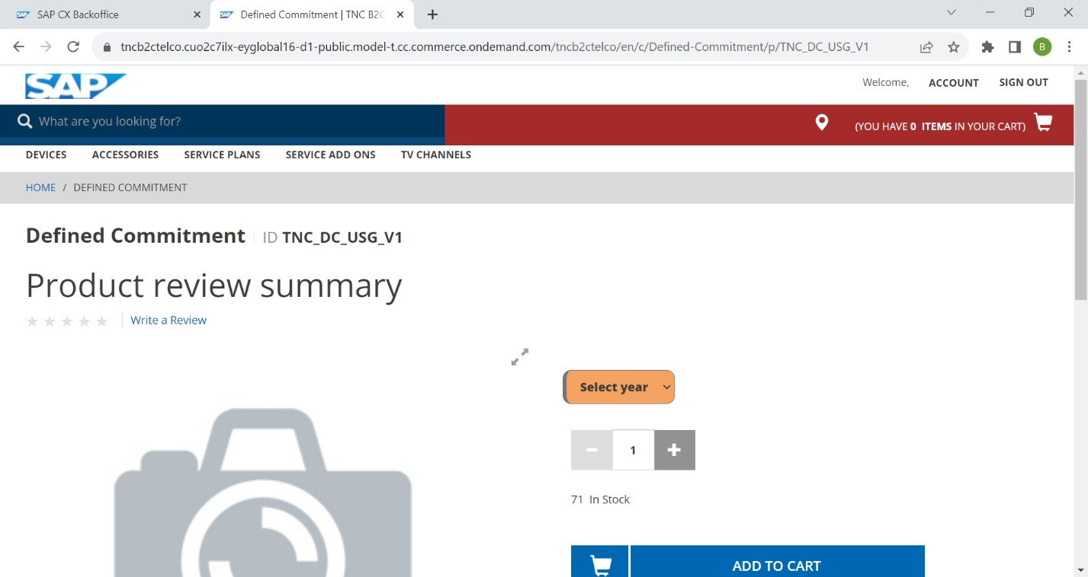

As part of Define commitment/Minimum contract, Customer will have a option to select the minimum contractual period from the given drop down and customer will have a option to provide the contract amount to each respective year.

Now In this case customer was selected “3years” as a contract period from the available drop down, and customer will get another setup of fields to provide the contract amount to each respective years. Below two screenshot for reference.

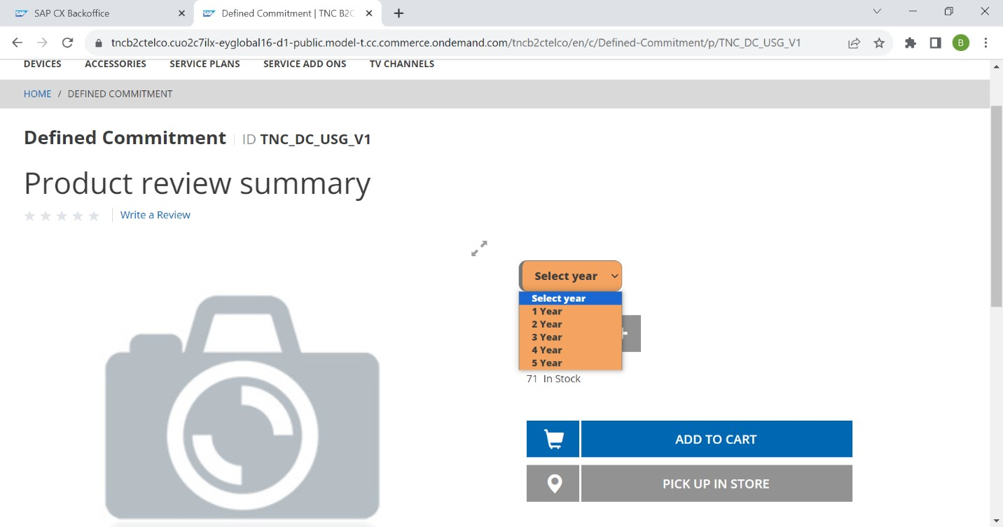

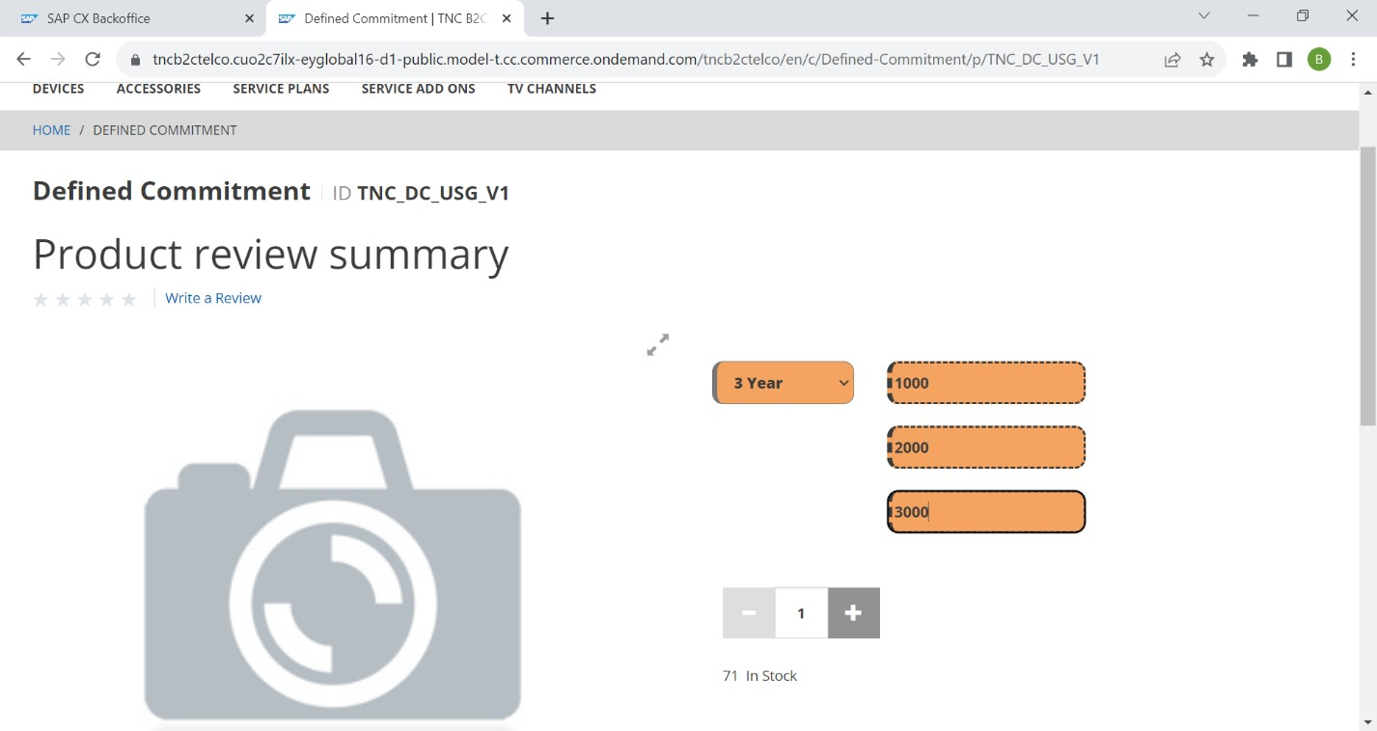

Now customer creating Minimum contract as 3 years and 1000, 2000 and 3000 as the Contractual amount by clicking add to cart.

After adding Product into cart, Now customer will have Two options, Either customer can create a Quote with the Minimum committed Business to get any discount on amount or customer has to other option to submit the “Define commitment/Minimum contract” to S4 by clicking the “Checkout” Button.

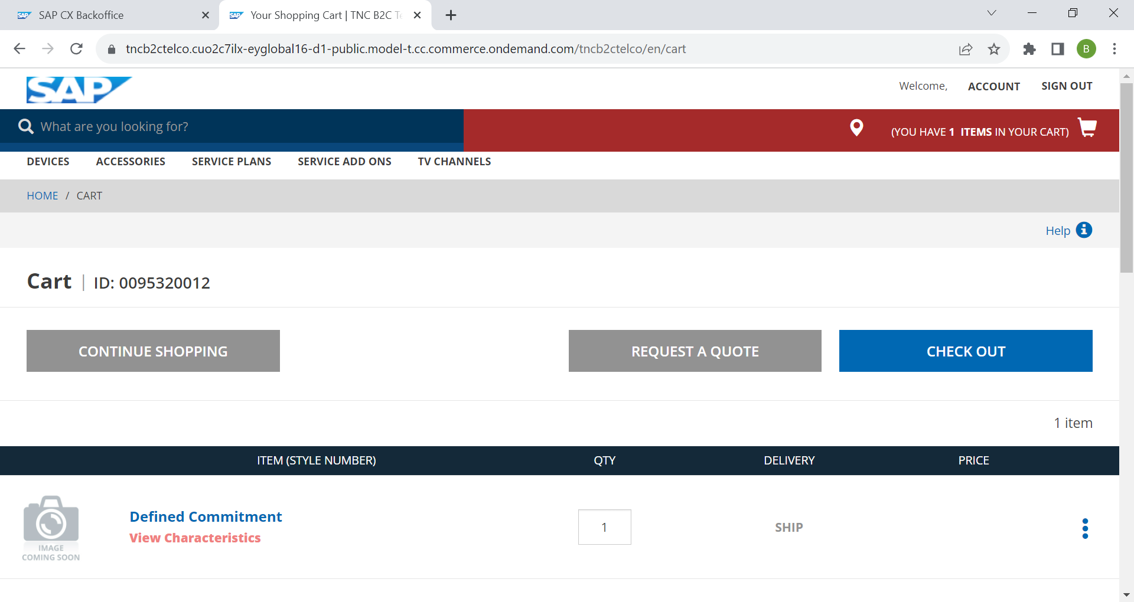

Now Customer was submitting the “Minimum contract” to CPQ to get extra discounts by clicking the “Request A Quote” button.

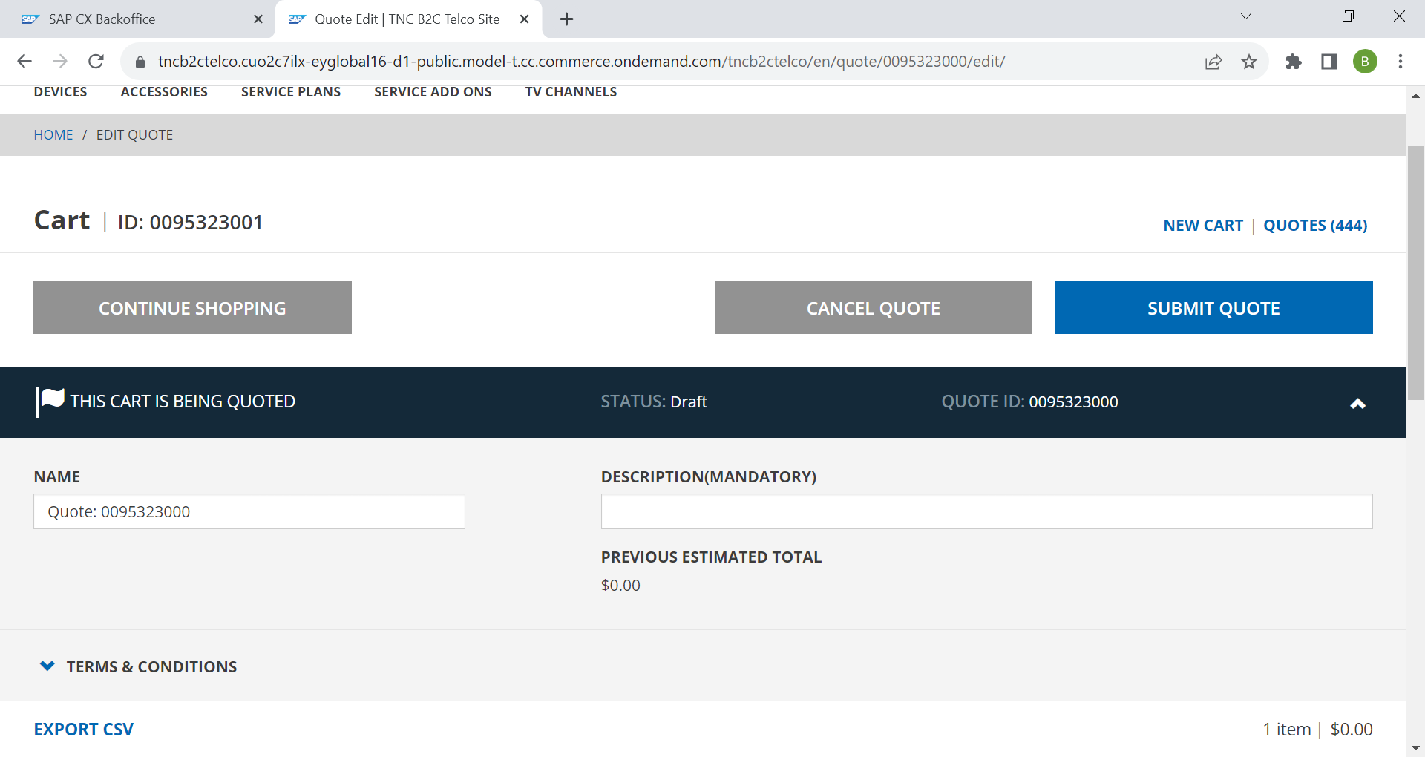

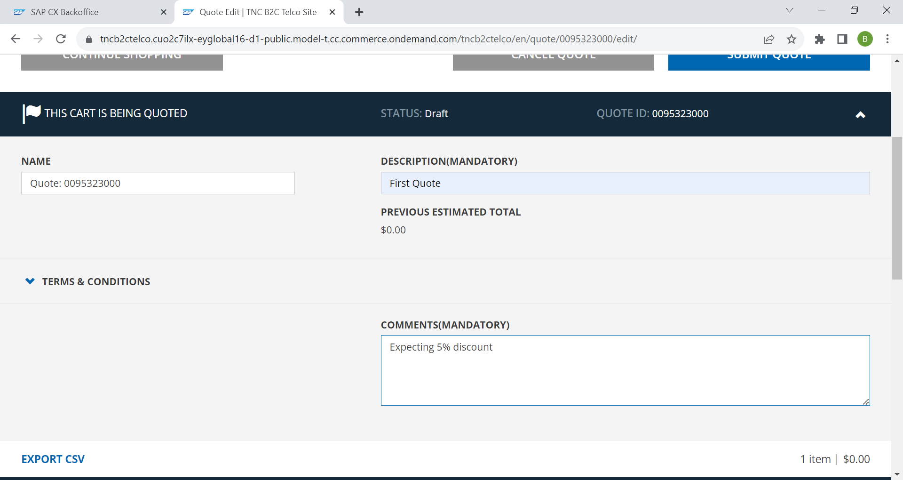

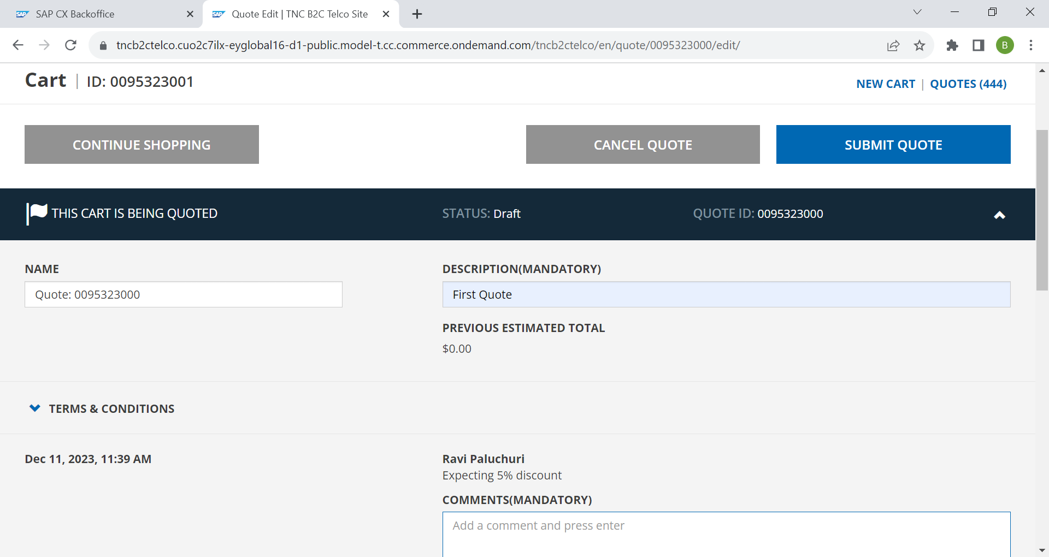

Once customer has updated his comments and Description of the Quote, they can be submitted it to CPQ for discount by clicking “Submit Quote” button.

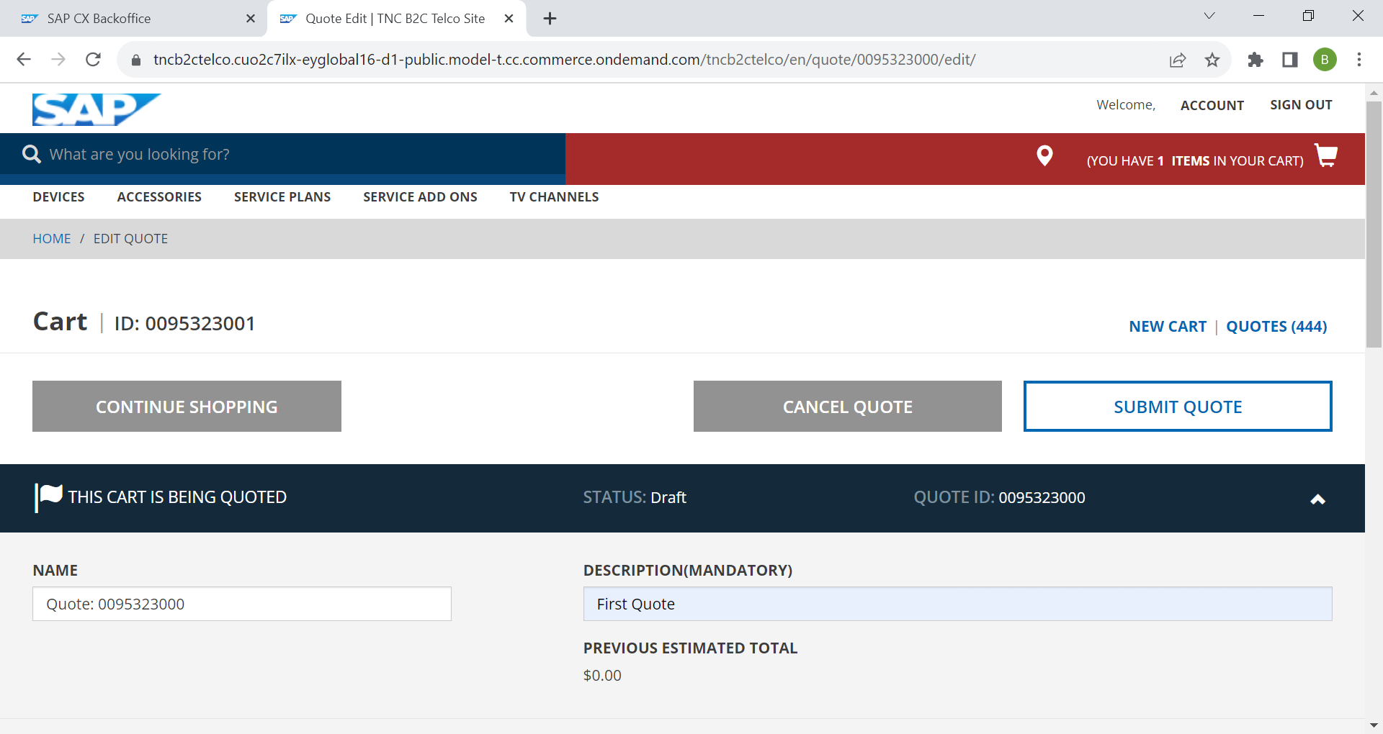

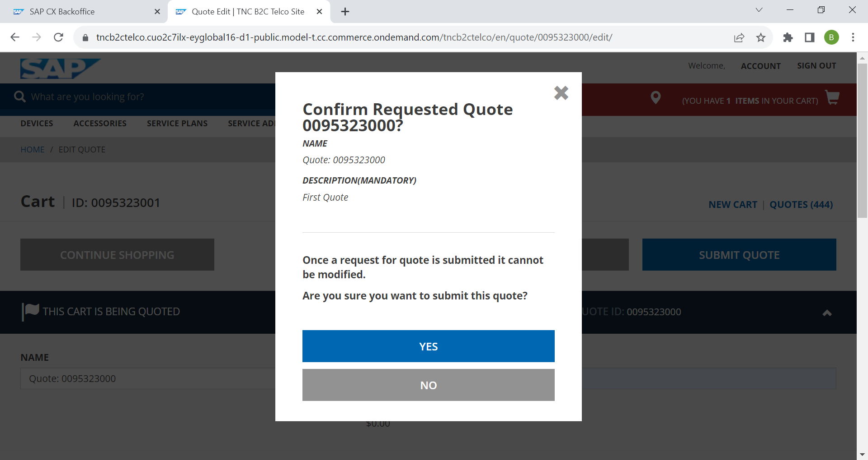

We need to Double check and confirm Before submitting it to CPQ by clicking the “YES” from the pop-up.

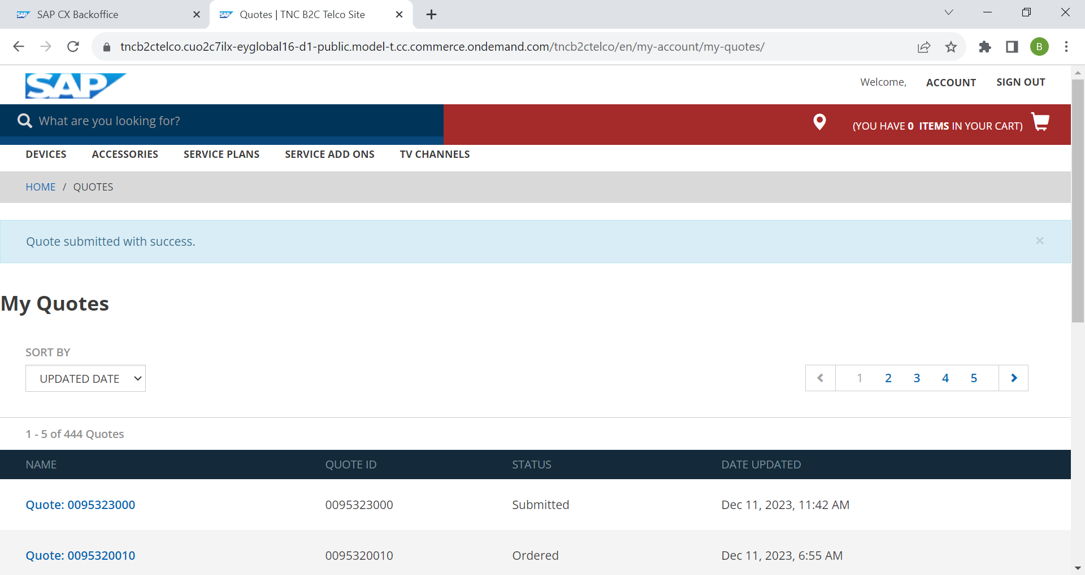

Once Quote was submitted the status will be “Submitted” from commerce cloud and Quote will get triggered to CPQ for Discounts.

Once we received back the Quote with discounts, we can verify same quote in “MY Quote” section with the update status as “Vendor Quote”.

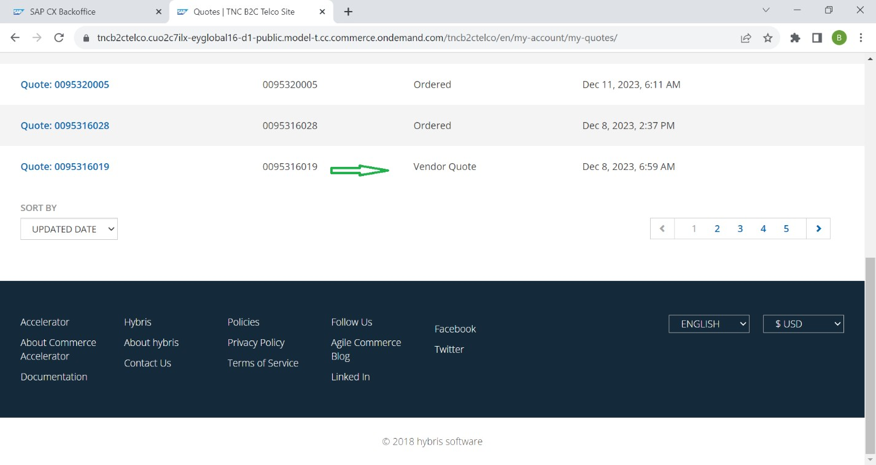

We can open the Vendor Quote by double clicking the Record. Below Detailed vendor Quote for reference.

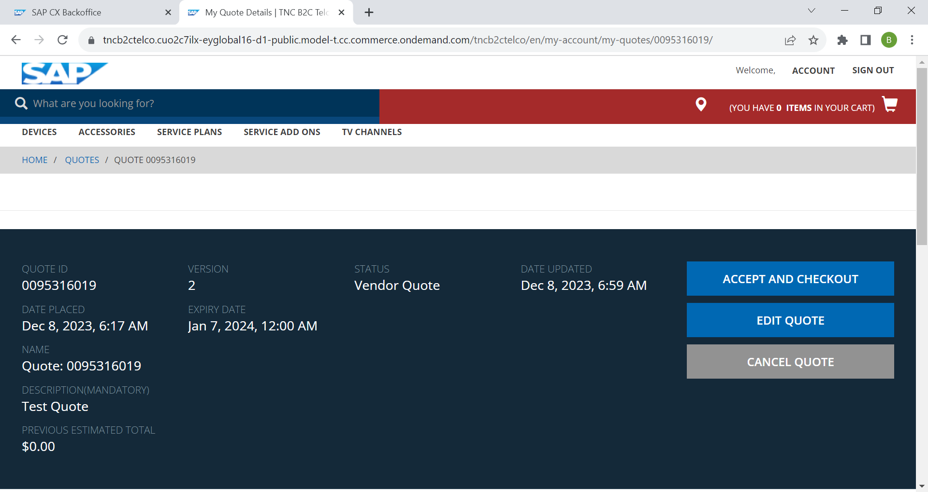

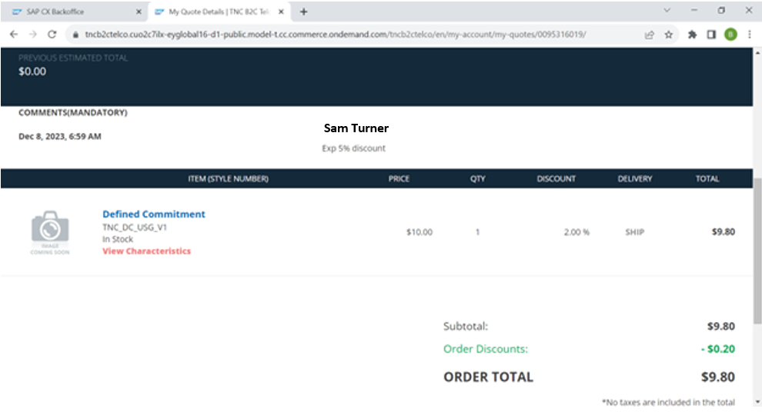

Now customer got the 2% discount on his subscription fee from CPQ business team, Now customer can accept and check out or cancel the discounted quote with below buttons for reference.



Now in this case customer was accepted and submitting the Quote as sales order to S4 by clicking the “ACCEPT AND CHECKOUT” button.

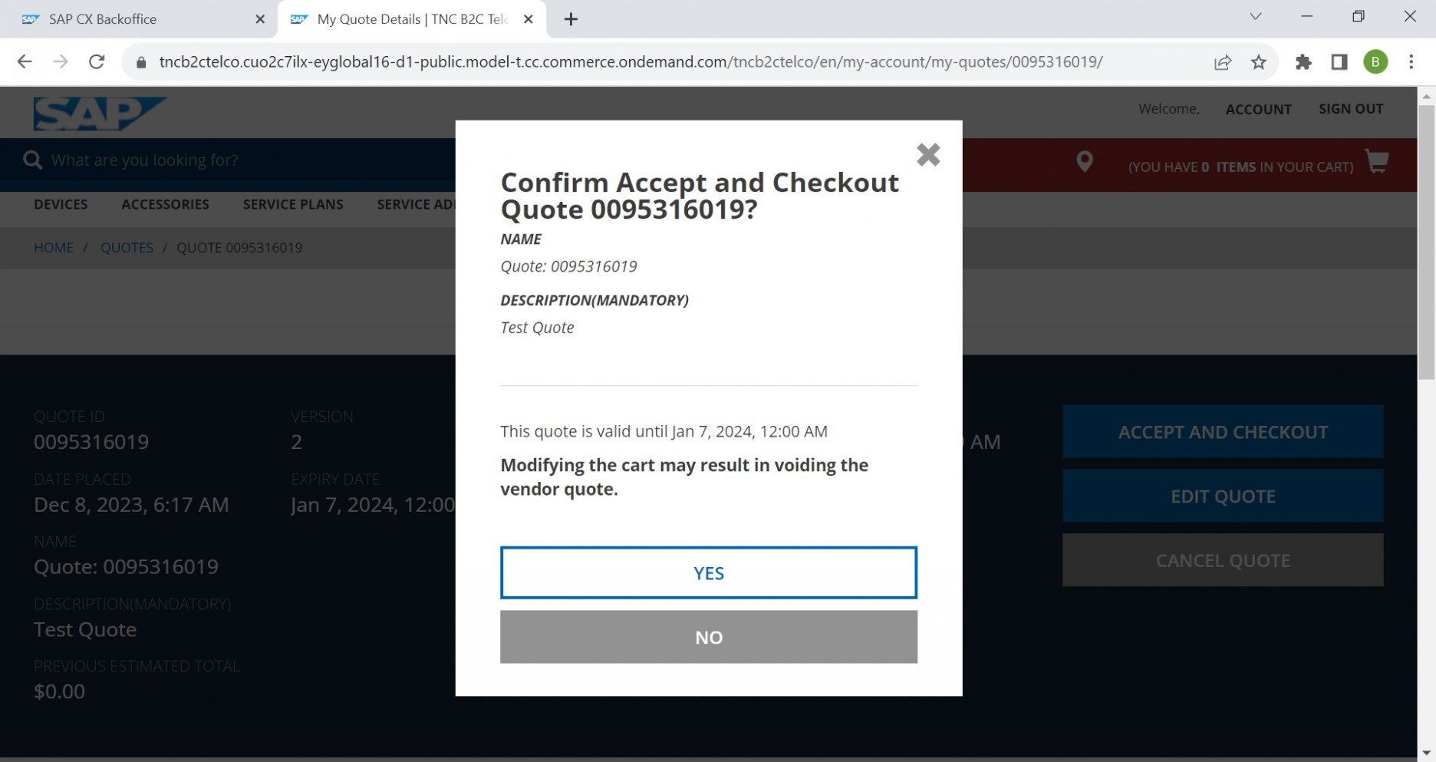

Now the vendor Quote will be converting into sales order. To Submit it as sales order customer has to give shipment, Billing and Payment details to fulfill it as sales order.

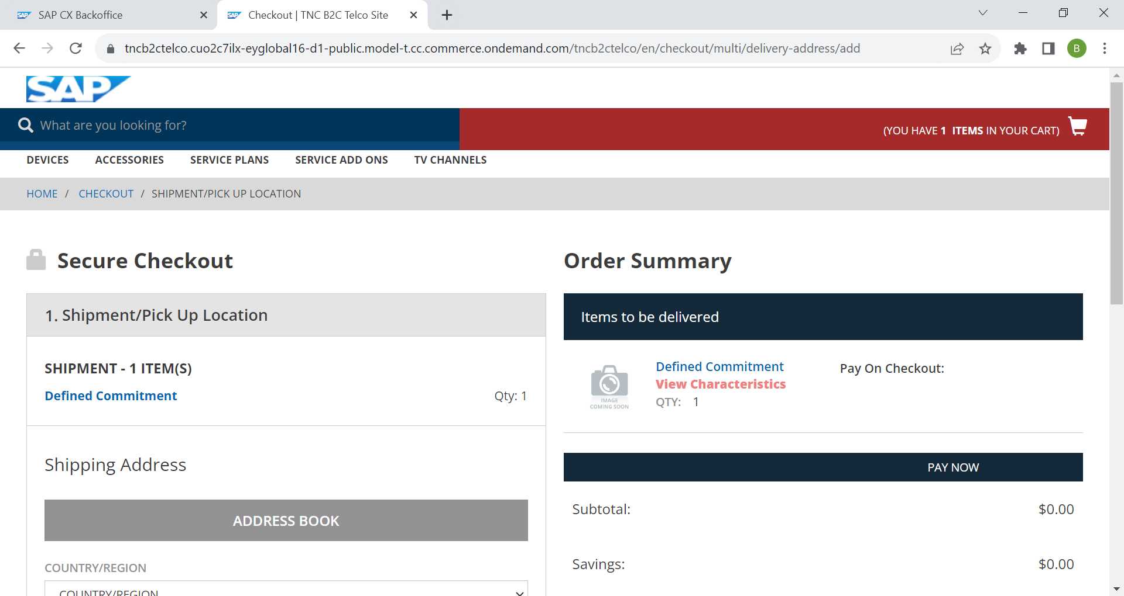

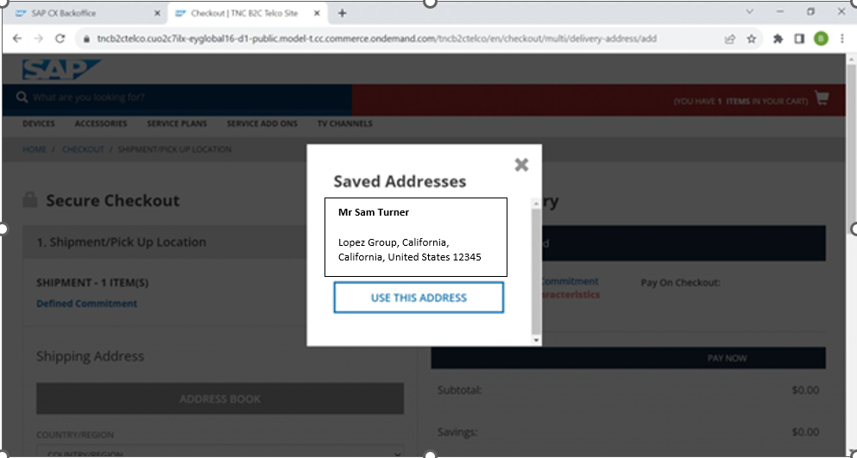

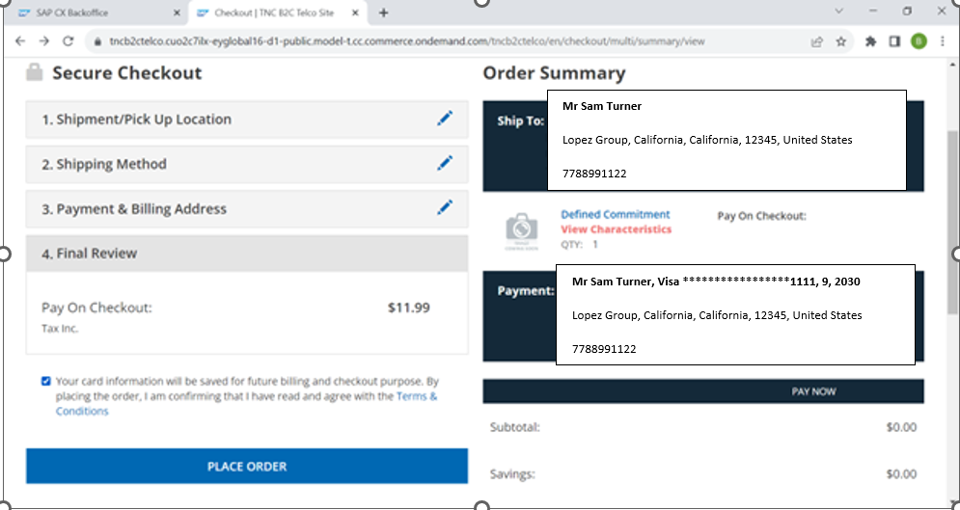

Customer has to verify his details and give the acceptance to place and order by clicking the “Terms and Conditions” check box. Above screenshot for reference.

After Final Review customer has to place an sales order by clicking the “PLACE ORDER” button. We will getting order confirmation page as follows.

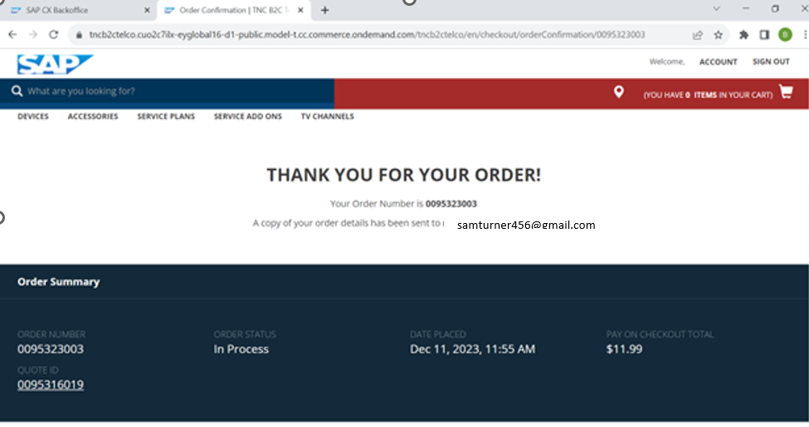

Now the sales order was placed with “Define commitment/ Minimum Contract” product from commerce cloud to S4 for further Financial flow and same can be verify from commerce back office.

To check the outbound payload from commerce to S4, we need to login into back office with below Details.

Back office URL : <https://backoffice.url>

Login id & Pwd : user/12345

# Define commitment for CPQ <-> Commerce Cloud

CPQ Tenant must be up and running with version quote 2.0 and should be integrated with Commerce and S4. Below URL’s for reference.

CPQ Shell URL : https://cpq-sales.calliduscloud.com/

Login id & Pwd : testsalesagent /test99

### Configuration Rationale / Additional Considerations

To Implement/ Submit Define commitment/Minimum Contract from commerce cloud, products should be replicated from S4 to CPQ. Once products is replicated, We can add discounts and commitment values from sales agent’s end.

We can modify the defined commitment values if required and should be able to push the same to Further systems.

### Configuration Settings

Add custom field:

Commitment Duration

|  |  |
| --- | --- |
| **Transaction Code** |  |
| **CPQ Path** | Admin -> User settings>Quotes> quotes layout> add Commitment duration. |

Commitment value for Y1

|  |  |
| --- | --- |
| **Transaction Code** |  |
| **Path** | Admin -> User settings>Quotes> quotes layout> add Commitment value for Y1 |

Commitment value for Y2

|  |  |
| --- | --- |
| **Transaction Code** |  |
| **Path** | Admin -> User settings>Quotes> quotes layout> add Commitment value for Y2 |

Commitment value for Y3

|  |  |
| --- | --- |
| **Transaction Code** |  |
| **Path** | Admin -> User settings>Quotes> quotes layout> add Commitment value for Y3 |

Commitment value for Y4

|  |  |
| --- | --- |
| **Transaction Code** |  |
| **Path** | Admin -> User settings>Quotes> quotes layout> add Commitment value for Y4 |

Commitment value for Y5

|  |  |
| --- | --- |
| **Transaction Code** |  |
| **Path** | Admin -> User settings>Quotes> quotes layout> add Commitment value for Y5 |

### Workflow from CPQ

Once the quote request is received in CPQ, Sales agent can modify the commitment values and override the same based on the set target.

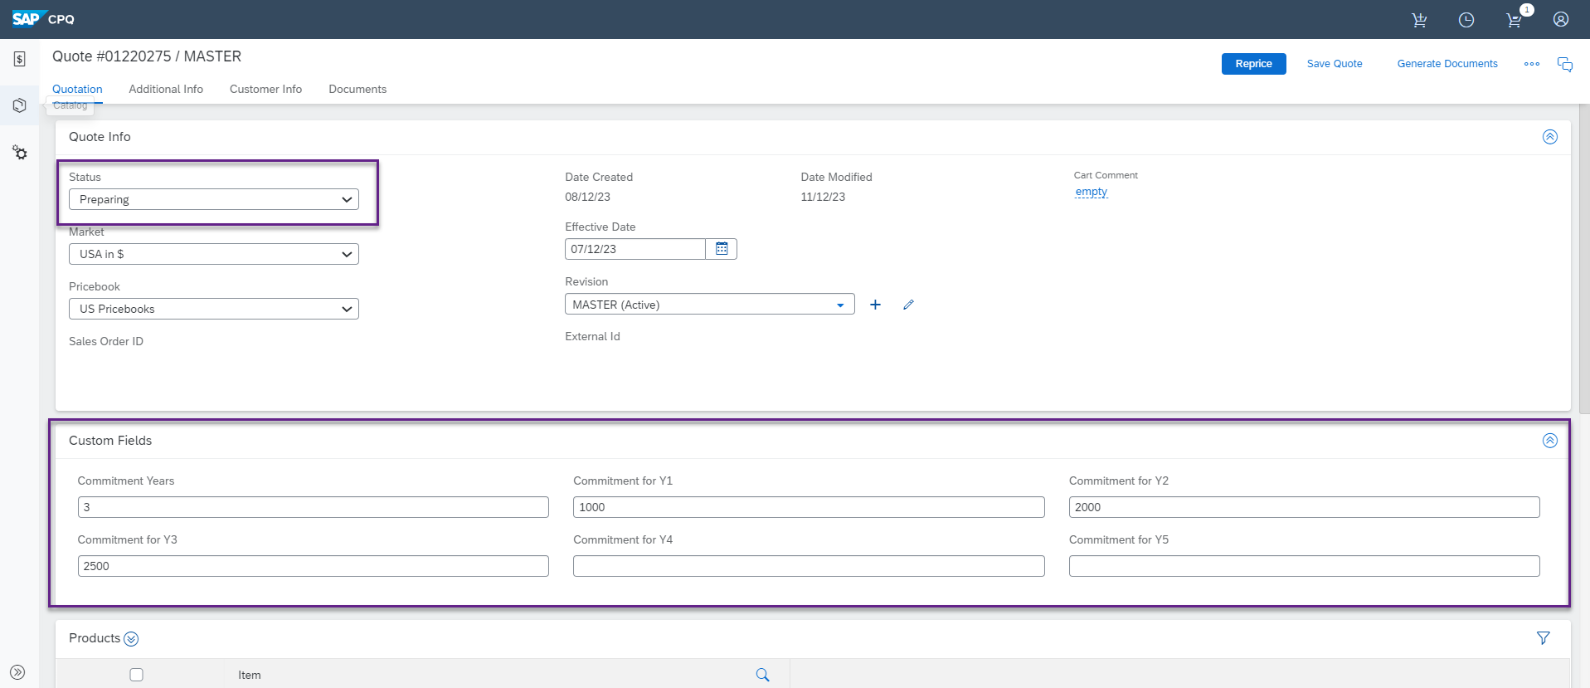

We can find the values received from customer and now the same agent will update the values and save the quote.

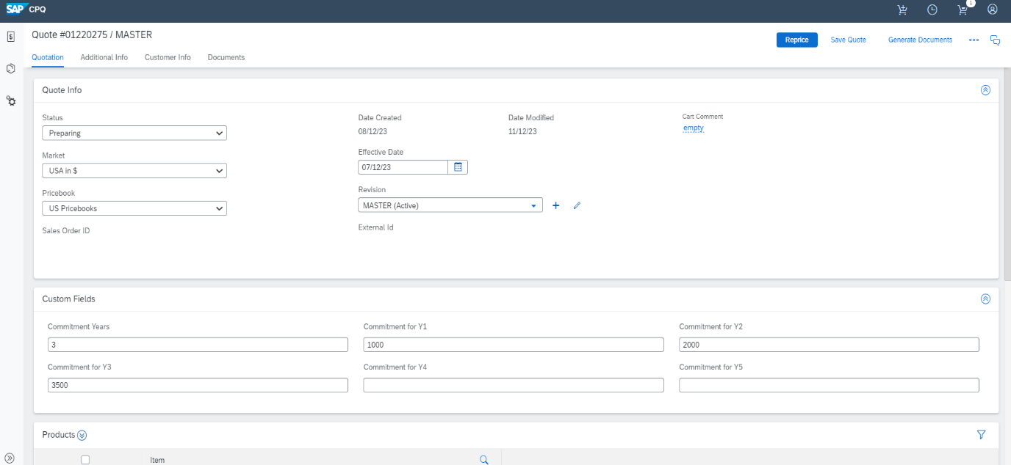

Now the sales agent will proceed to add the requested discounts

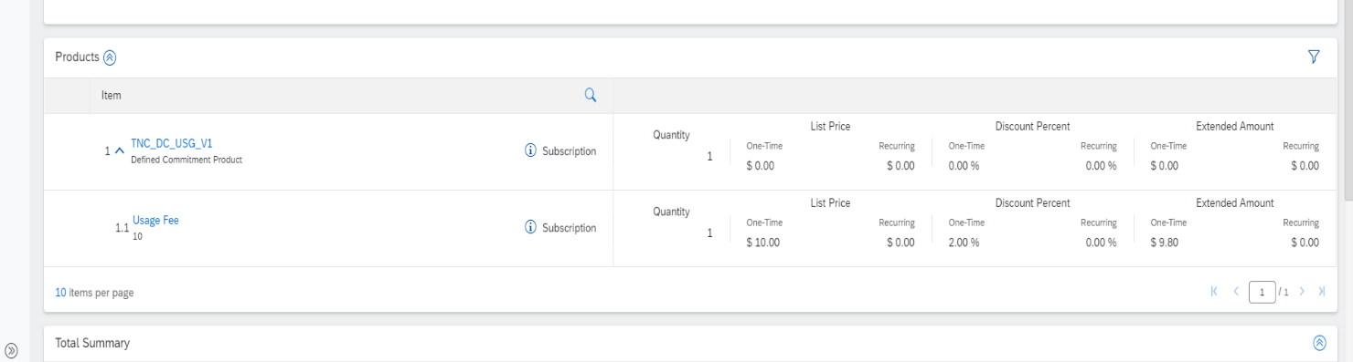

Now the sales agent will send the quote back to commerce cloud for further processing and sales order creation upon customer approval.

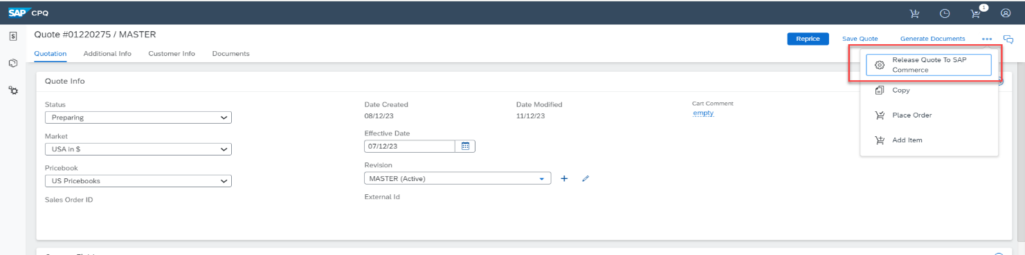

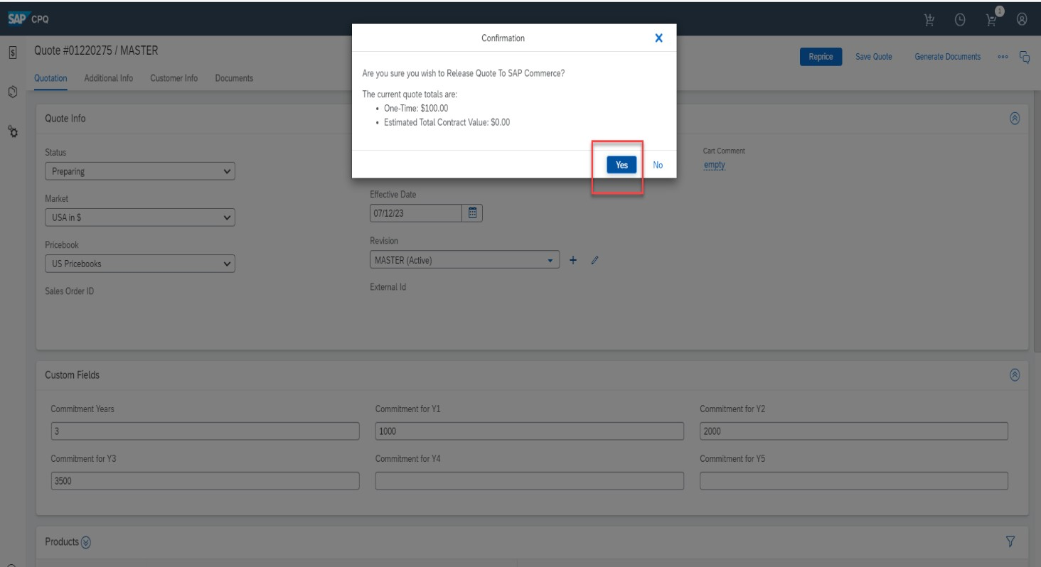

### Status Flow details from CPQ

|  |  |
| --- | --- |
| Once the quote reaches from Commerce cloud to CPQ | Preparing |
| Once the quote in approved internally in CPQ | Approved |
| Once the quote is rejected | Rejected |
| Post the internal approval in CPQ, quote is sent back to SAP Commerce Cloud | Release to commerce |
| When sales order is placed in SAP commerce | Order placed |

**EY** | Building a better working world

EY exists to build a better working world, helping to create long-term value for clients, people and society and build trust in the capital markets.

Enabled by data and technology, diverse EY teams in over 150 countries provide trust through assurance and help clients grow, transform and operate.

Working across assurance, consulting, law, strategy, tax and transactions, EY teams ask better questions to find new answers for the complex issues facing our world today.

EY refers to the global organization, and may refer to one or more, of the member firms of Ernst & Young Global Limited, each of which is a separate legal entity. Ernst & Young Global Limited, a UK company limited by guarantee, does not provide services to clients. Information about how EY collects and uses personal data and a description of the rights individuals have under data protection legislation are available via ey.com/privacy. EY member firms do not practice law where prohibited by local laws. For more information about our organization, please visit ey.com.

Ernst & Young LLP is a client-serving member firm of   
Ernst & Young Global Limited operating in the US.

© 2022 EYGM Limited.   
All Rights Reserved.

2111-3904412  
ED None

This material has been prepared for general informational purposes only and is not intended to be relied upon as accounting, tax or other professional advice. Please refer to your advisors for specific advice.

ey.com